Sphero Research Project
Setting Up Visual Studio Code & Sphero Code

First Time Setup:

- Download and Install Microsoft Visual Studio Code (VS Code):
(Mac/Windows): https://code.visualstudio.com/download

- Open VS Code File Open Folder

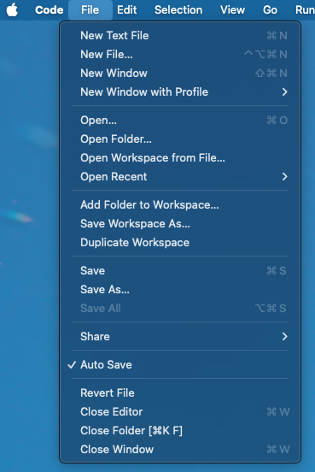

- Create a New Folder:
- Make a new folder called “Sphero-Research-Project” wherever you would like to save the project files.

- Click Open: to use this empty folder as your project directory.
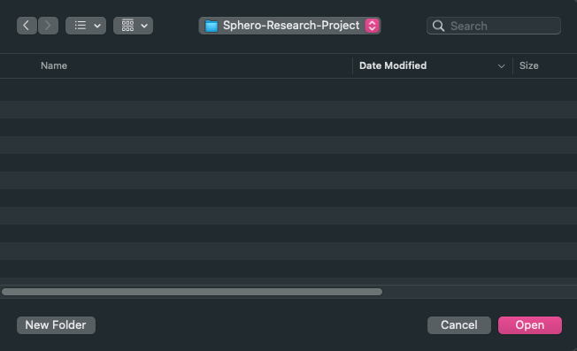

- Click Terminal New Terminal
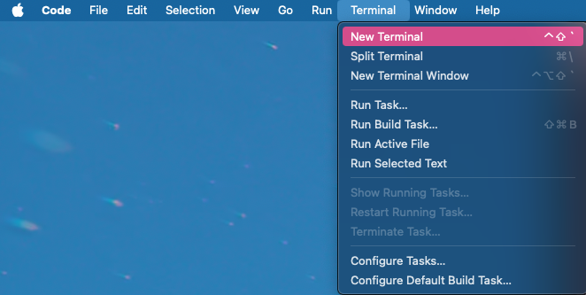

- Clone the Git Repository: get a local copy of all necessary files
- Copy and paste this into your new terminal:
  - git clone git@github.com:amanda-pang/Sphero-Research-Participants.git
Running your Sphero
- Open VS Code File Open Folder Sphero-Research-Project
- Open the folder where you’ve saved all the project files

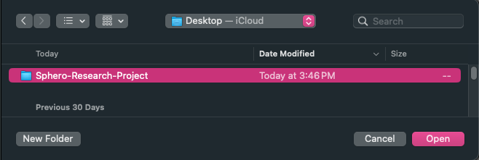
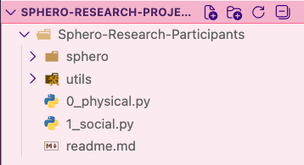

- Click Terminal New Terminal

- Copy and Paste this into your terminal: Move into the Sphero-Research-Participants directory
  - cd Sphero-Research-Participants

- Activate your Virtual Environment: use correct versions of programs provided in /sphero folder
- Copy and paste this into your terminal:
  - source sphero/bin/activate

- Running Physical / Social: Sphero Research Conditions
5a. If you are currently in the “Physical” arm, click the file “0_physical.py”
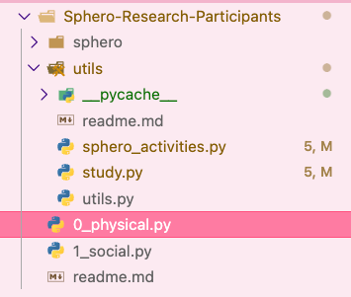
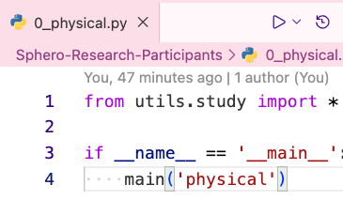
- Then click the “run” button on the top right.

5b. If you are currently in the “Social” arm, click the file “1_social.py”
- Then click the “run” button on the top right.
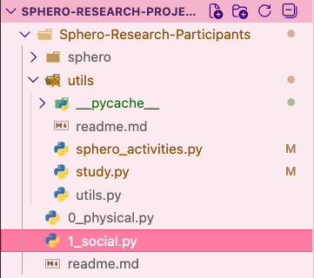
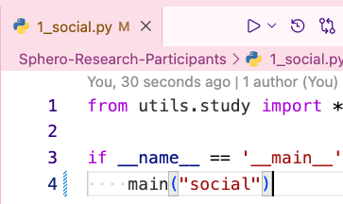

- That’s it! Just leave your Sphero buddy nearby while you work, and leave VS Code open and running in the background.
- Use our website to track the start and end of your study session, and log when you complete a stretch.
Disconnect & End
- When you are done with your studying/working session:
- Disconnect your Sphero and quit the program by clicking the “Stop” button in VS Code.
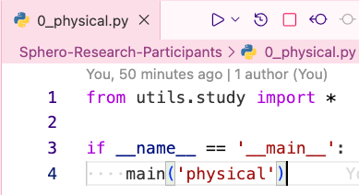

- Navigate to our website, and click “End Study Session”.
- If you forget to log any events (start/end time, or a stretch break), you may manually enter this information on the “Manual Entry” tab.

Thank you for participating in our study!!

